

**Quick Start Tutorials: How to compile an Agent**

If you are using **Eclipse**, the agent file is often compiled automatically and can be found in the “bin” folder in your workspace. If the file has not been compiled automatically, you can compile it by selecting **project🡪 Clean…** (see figure__).

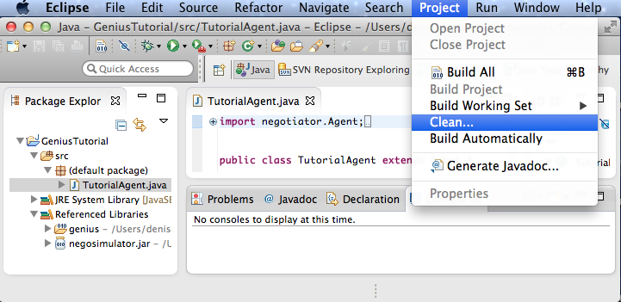

To manually compile the agent, first, place the package directory with all the files (eg. examplepackage directory with ExampleAgent.java**)** in the directory containing the **negotiator.jar** file**.** Then, in the computer’s Terminal enter the command line:

**javac -cp negosimulator.jar examplepackage/ExampleAgent.java**